E-Project Eproject Guide
Beauty Of Beaches

Group Members

- Muhammad Hanzala
Student:1729048

- Muhammad Zia ur Rehman
Student:1729049

- Usman Kamran
Student:17229389

- Daniyal Rizwan
Student:1728582

Faculty Members

Teacher: Miss Neha Shah
Coordinator: Miss Maha

INTRODUCTION

BEAUTY OF BEACHES

The beauty of beaches has always attracted people with its natural charm, peaceful environment, and refreshing atmosphere. Beaches are a wonderful combination of golden sand, sparkling blue water, gentle waves, cool sea breeze, and beautiful sunsets. They provide a perfect place for relaxation, recreation, tourism, and spending quality time with family and friends.
In today's digital world, technology provides an excellent way to explore and present the natural beauty of beaches. A well-designed web application can provide users with useful information about different beaches, their locations, attractions, activities, and natural surroundings in an interactive and attractive manner.
Keeping the above concept in mind, this E-Project, “Beauty of Beaches”, is designed to provide an interactive platform where users can explore and learn about beautiful beaches. The project demonstrates how web technologies can be used to present information in an organized, user-friendly, and visually appealing way.
The project provides an opportunity to apply technical concepts in a practical environment and develop a complete application using various tools and technologies. It also helps students understand how individual concepts can be integrated together to create a useful real-life application.
- OBJECTIVE OF THE PROJECT
The main objective of the “Beauty of Beaches” project is to develop an attractive and informative web application that provides users with information about beaches and their natural beauty.
The project aims to:
- Provide information about famous and beautiful beaches.
- Display attractive images and descriptions of beaches.
- Provide information about beach locations and attractions.
- Help users explore different beaches through an easy-to-use interface.
- Present information in an organized and visually appealing manner.
- Provide details about activities that can be enjoyed at beaches.
- Demonstrate the practical implementation of web development concepts.
- Develop a larger and more useful application by integrating different features.
- Improve technical skills through real-life project implementation.
- Create a user-friendly environment for exploring the beauty of beaches.
The objective of this project is not only to display information but also to provide a practical example of how different web development concepts can be combined to create an interactive and meaningful application.

Screenshots

HTML CODE:
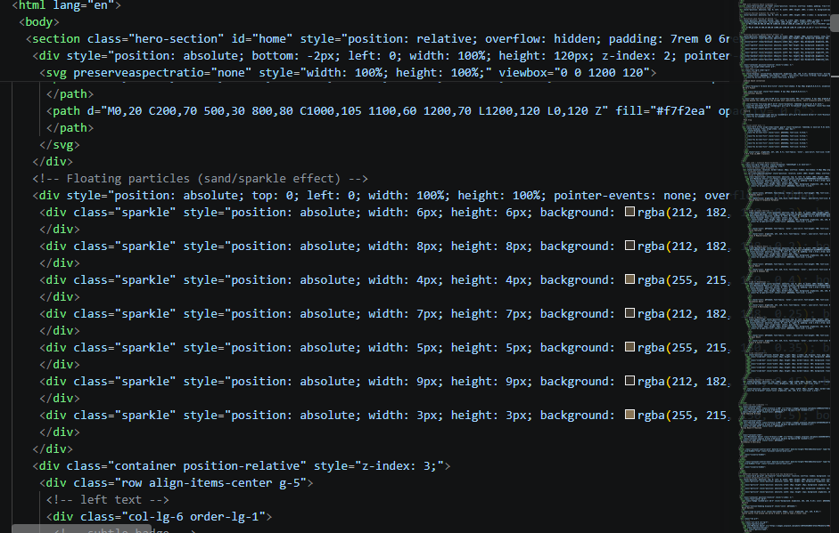

STYLE.CSS CODE:

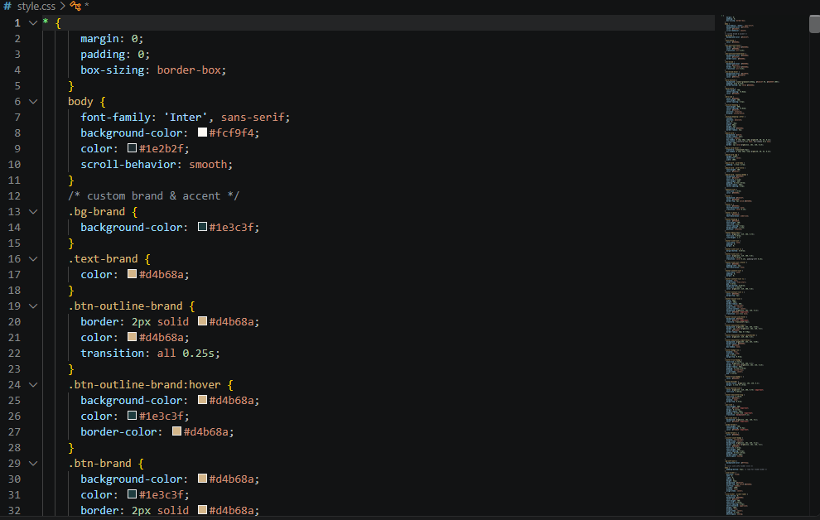

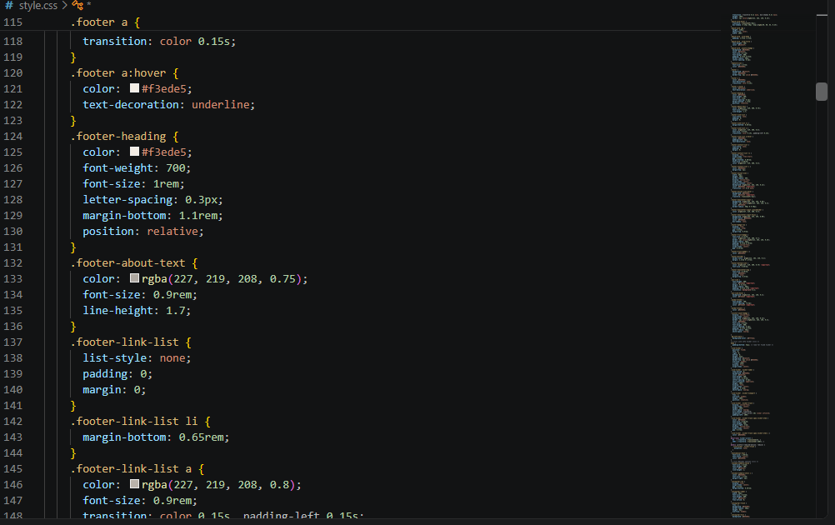
SCRIPT.JS CODE:
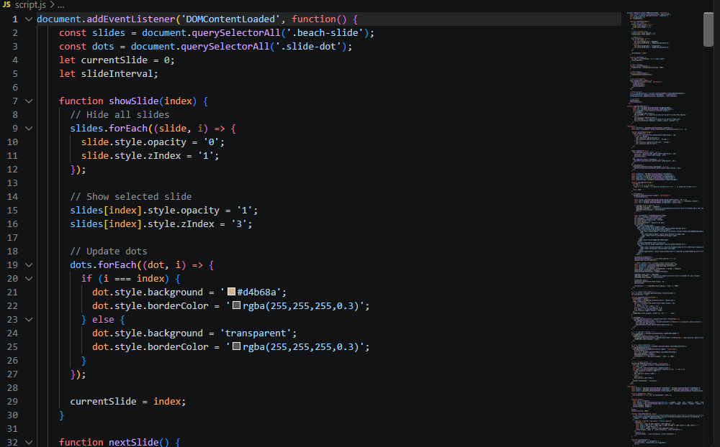

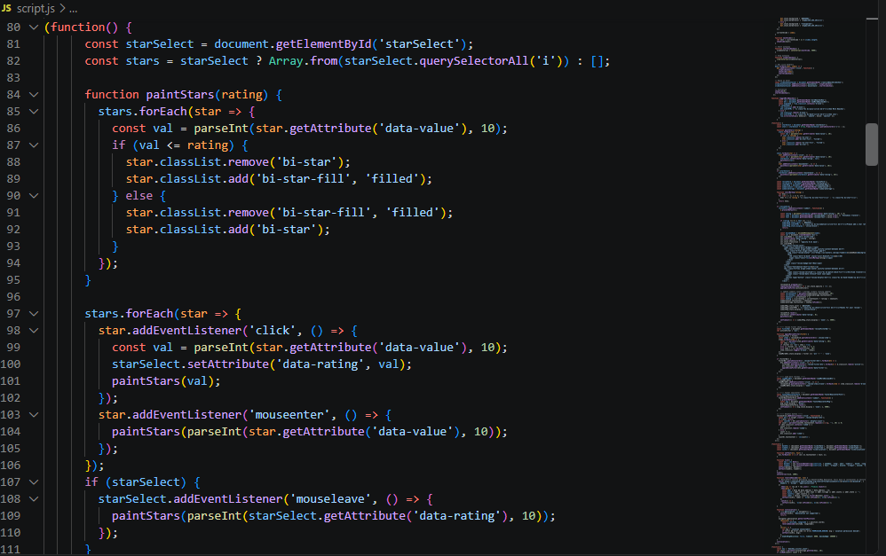

HOME PAGE :

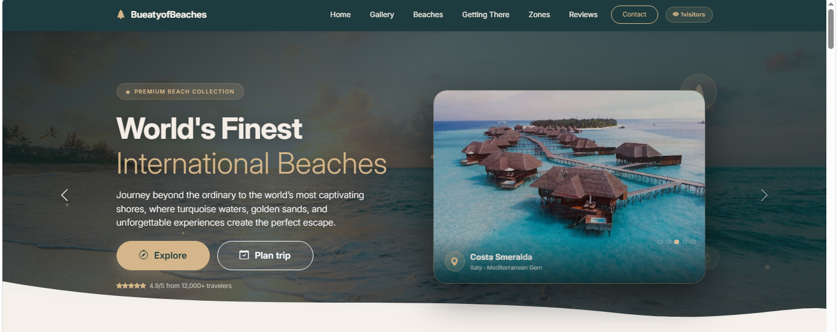

GALLERY PAGE:

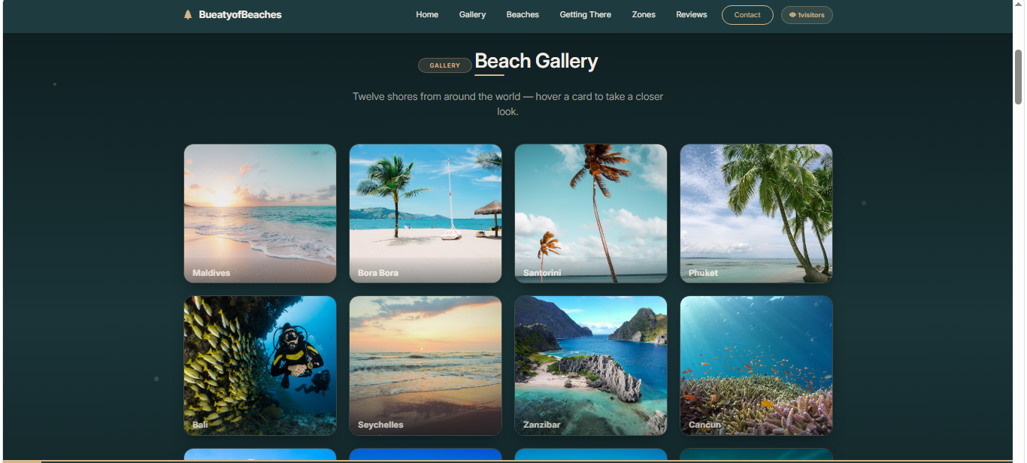
REVIEW PAGE :

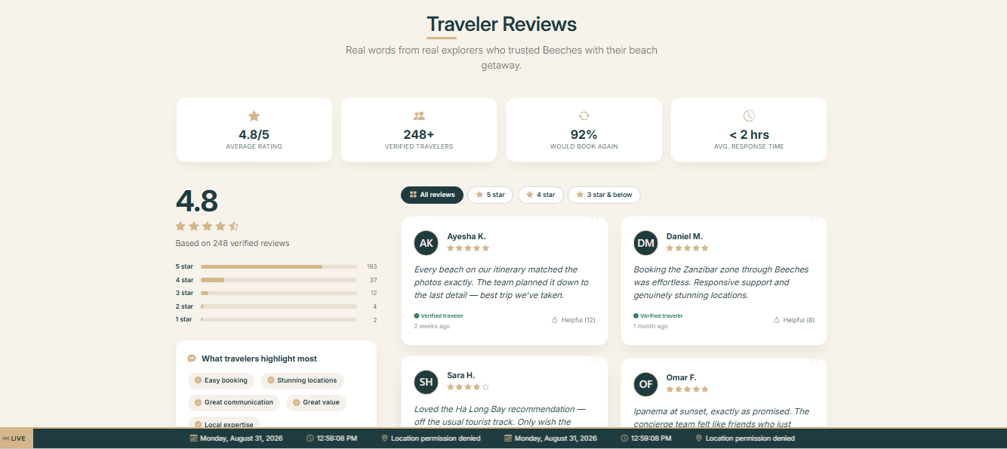

THANK YOU

